|  |  |
| --- | --- |
| Learning MS Word  Sir Haris Naseer | Abstract  [Draw your reader in with an engaging abstract. It is typically a short summary of the document. When you’re ready to add your content, just click here and start typing.]  Haris Naseer  [Course title] |

# Name: Haris Naseer

# Class: 2408F1

V

ideo provides a powerful way to help you prove your point. When you click Online Video, you can paste in the embed code for the video you want to insert. You can also type a keyword to search online for the video that best fits your document. To make your document look professionally produced, Word provides header, footer, cover page, and text box designs that complement each other.

Ctrl + [ -> font size decrease

Ctrl + ]-> font size increase

For example, you can insert a matching cover page, header, and sidebar. Click Insert and then choose the elements you want from the different galleries. Themes and styles also help keep your document coordinated. When you click Design and choose a new Theme, the pictures, charts, and SmartArt graphics change to match your new theme. Tuesday, July 30, 2024

**When you apply styles, your headings change to match the new theme. Save**

**time in Word with new buttons that show up where you need them. To change**

**the way a picture fits in your document, click it and a button for layout options**

**appears next to it. When you work on a table, click where you want to insert a row or a column, and then click the plus sign.**

Y

V

G

12

10

4

When you click Online Video, you can paste in the embed code for the video you want to insert. You can also type a keyword to search online for the video that best fits your document. To make your document look professionally produced, Word provides header, footer, cover page, and text box designs that complement each other. For example, you can insert a matching cover page, header, and sidebar.

Reading is easier, too, in the new Reading view. You can collapse parts of the document and focus on the text you want. If you need to stop reading before you reach the end,

Word remembers where you left off - even on another device. Video provides a powerful way to help you prove your point.



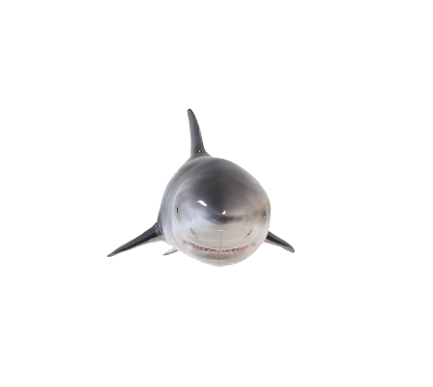

shark



03172021951

**Hello How are you?**

[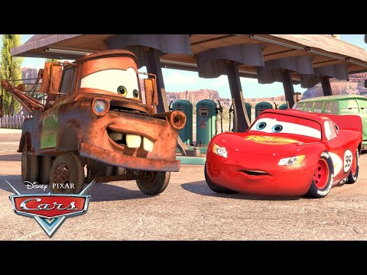](https://www.youtube.com/watch?v=JRQaxj_Yw00)

Gates was born and raised in Seattle, Washington. In 1975, he and Allen founded Microsoft in Albuquerque, New Mexico. Gates led the company as its chairman and chief executive officer until stepping down as [CEO](https://www.google.co.uk/) in January 2000, succeeded by Steve Ballmer, but he remained chairman of the board of directors and became chief software architect. During the late 1990s, he was criticized for his business tactics, which were considered anti-competitive.

©Aptech Pakistan®

LinkedIn: [haris_naseer](https://www.linkedin.com/in/haris-naseer/)

ewrefsdf



$$24℉ + n^{2}+1=∫y^{4}\int_{3}^{2}{x}^2$$

|  |  |  |  |
| --- | --- | --- | --- |
| S.No. | Name | Percentage | Result |
| 1 | Haris | 95 | Pass |
| 2 | Owais | 54 | Pass |
| 3 | Afzal | 60 | Pass |
| 4 | Usama | 35 | Fail |

|  |  |
| --- | --- |
| ITEM | NEEDED |
| Books | 1 |
| Magazines | 3 |
| Notebooks | 1 |
| Paper pads | 1 |
| Pens | 3 |
| Pencils | 2 |
| Highlighter | 2 colors |
| Scissors | 1 pair |

|  |  |  |  |  |
| --- | --- | --- | --- | --- |
| Sno | Date | Content | Pg | Sign |
|  |  |  |  |  |
|  |  |  |  |  |
|  |  |  |  |  |
|  |  |  |  |  |
|  |  |  |  |  |
|  |  |  |  |  |
|  |  |  |  |  |
|  |  |  |  |  |
|  |  |  |  |  |
|  |  |  |  |  |
|  |  |  |  |  |
|  |  |  |  |  |

# Heading

Video provides a powerful way to help you prove your point. When you click Online Video, you can paste in the embed code for the video you want to add. You can also type a keyword to search online for the video that best fits your document. To make your document look professionally produced, Word provides header, footer, cover page, and text box designs that complement each other. For example, you can add a matching cover page, header, and sidebar. Click Insert and then choose the elements you want from the different galleries.

Themes and styles also help keep your document coordinated. Whenever you click Design and choose a new Theme, the pictures, charts, and SmartArt graphics change to match your new theme. When you apply styles, your headings change to match the new theme. Save time in Word with new buttons that show up where you need them.   
To change the way a picture fits in your document, click it and a button for layout options appears next to it. When you work on a table, click where you want to add a row or a column, and then click the plus sign.

Reading is easier, too, in the new Reading view. You can collapse parts of the document and focus on the text you want. If you need to stop reading before you reach the end, Word remembers where you left off - even on another device. Video provides a powerful way to help you prove your point. When you click Online Video,

you can paste in the embed code for the video you want to add. You can also type a keyword to search online for the video that best fits your document.

To make your document look professionally produced, Word provides header, footer, cover page, and text box designs that complement each other. For example, you can add a matching cover page, header, and sidebar. Click Insert and then choose the elements you want from the different galleries. Themes and styles also help keep your document coordinated. When you click Design and choose a new Theme, the pictures, charts, and SmartArt graphics change to match your new theme. When you apply styles, your headings change to match the new theme.